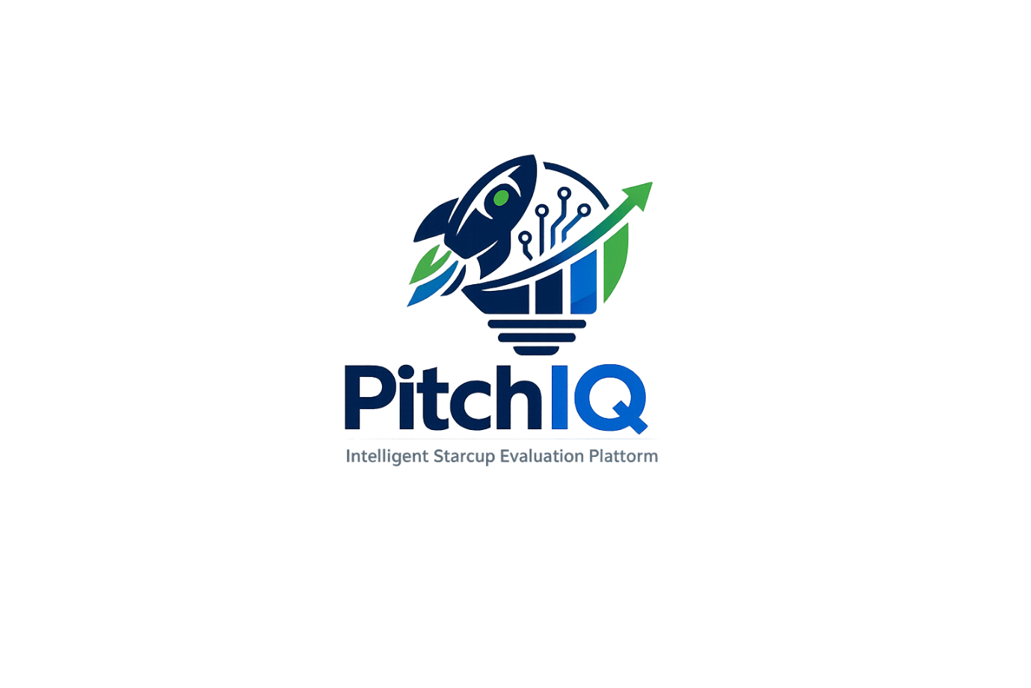
Pitch IQ – Intelligent Start-up Evaluation Platform

- Project Description
- Tasks to Implement
- User Authentication.
- Start-up Pitch Management.
- Start-up Data Collection.
- Machine Learning Analysis.
- Recommendation Engine.
- Dashboard & Reports.
- REST API Development.
- Uniqueness of the Project
- Technologies Required
- Future Enhancements

1. Project Description

Pitch IQ – Intelligent Start-up Evaluation Platform
Pitch IQ is a full-stack web application designed to help entrepreneurs, students, and start- up enthusiasts evaluate and improve their start-up ideas before presenting them to investors, mentors, or incubation centres. The platform provides a structured approach to analysing start-up pitches by collecting key business information such as the problem statement, proposed solution, target audience, market opportunity, business model, competitive landscape, and revenue strategy.
The application leverages Machine Learning to assess the overall quality and feasibility of a start-up idea based on predefined evaluation parameters. It generates an overall start-up score along with detailed insights into innovation, market potential, business viability, and scalability. Additionally, the system provides personalized recommendations to help users strengthen their business proposals.
The platform is developed using Python, Django, Django REST Framework, Scikit-learn, MySQL, HTML, CSS, Bootstrap, and JavaScript, following a modular architecture that supports future enhancements such as AI-based recommendations, investor matchmaking, and cloud deployment.
Pitch IQ serves as a valuable tool for start-up incubation centres, entrepreneurship programs, hackathons, and aspiring founders by enabling data-driven decision-making and improving the quality of start-up pitches.

2. Tasks to Implement
The implementation of Pitch IQ consists of the following modules:

Module 1 – User Authentication
- User Registration
- Secure Login and Logout
- Password Encryption
- User Profile Management

Module 2 – Start-up Pitch Management
- Create New Start-up Pitch
- Edit Existing Pitch
- Delete Pitch
- View Submitted Pitches

Module 3 – Start-up Data Collection
The system collects:
- Start-up Name
- Problem Statement
- Proposed Solution
- Target Audience
- Business Model
- Revenue Model
- Market Size
- Competitor Analysis
- Team Details
- Funding Requirement

Module 4 – Machine Learning Analysis
- Data Pre-processing
- Feature Extraction
- Start-up Quality Prediction
- Start-up Score Generation
- Business Feasibility Evaluation

Module 5 – Recommendation Engine
- Identify Missing Business Components
- Suggest Improvements
- Highlight Strengths
- Recommend Areas for Improvement

Module 6 – Dashboard & Reports
- Display Overall Start-up Score
- View Detailed Analysis Report
- Track Previous Start-up Evaluations
- Compare Multiple Start-up Ideas

Module 7 – REST API Development
Develop REST APIs for:
- User Management
- Start-up Submission
- Start-up Analysis
- Dashboard Data
- Report Retrieval

3. Uniqueness of the Project
Pitch IQ is not just a start-up management system; it is an intelligent start-up evaluation platform that combines full-stack web development with machine learning to provide meaningful business insights.
The project stands out because it:
- Evaluates start-up ideas using machine learning instead of simple rule-based validation.
- Generates an overall start-up quality score based on multiple business parameters.
- Provides personalized recommendations to improve business proposals.
- Enables users to track and compare multiple start-up ideas.
- Exposes REST APIs, making the platform scalable and ready for integration with mobile applications or third-party services.
- Addresses a real-world problem faced by entrepreneurs and start-up founders.
- Demonstrates practical skills in backend development, database management, REST API development, and machine learning, making it highly valuable for placement opportunities.

4. Technologies Required

Frontend
- HTML5
- CSS3
- Bootstrap 5
- JavaScript

Backend
- Python 3.x
- Django

API Development
- Django REST Framework (DRF)

Database
- MySQL

Machine Learning
- Scikit-learn
- Pandas
- NumPy

Version Control
- Git
- GitHub

Development Environment
- Visual Studio Code

5. Future Enhancements
The proposed system can be further enhanced with advanced technologies and intelligent features to improve user experience and business analysis capabilities.
Future enhancements include:
- Integration of Large Language Models (LLMs) for AI-powered feedback and pitch refinement.
- Voice-based start-up pitch evaluation using speech recognition.
- Investor recommendation system based on start-up domain and funding stage.
- Real-time market trend analysis using external business data.
- Start-up success probability prediction using advanced machine learning models.
- Automated PDF report generation and email notifications.
- Team collaboration features for co-founders and mentors.
- Multi-language support to reach a wider audience.
- Cloud deployment using AWS, Azure, or Google Cloud Platform.
- Mobile application for Android and iOS with synchronized data.
- Analytics dashboard with visual charts and start-up performance metrics.

